**Spring Core & Maven - Week 3**

**Name:Krishna prakash**

**Id: 6373973**

**1. Configuring a Basic Spring Application**

**📄 pom.xml snippet:**

<dependency>

<groupId>org.springframework</groupId>

<artifactId>spring-context</artifactId>

<version>5.3.34</version>

</dependency>

**📄 applicationContext.xml:**

<beans xmlns="http://www.springframework.org/schema/beans"

xmlns:xsi="http://www.w3.org/2001/XMLSchema-instance"

xsi:schemaLocation="http://www.springframework.org/schema/beans http://www.springframework.org/schema/beans/spring-beans.xsd">

<bean id="bookRepository" class="com.library.repository.BookRepository"/>

<bean id="bookService" class="com.library.service.BookService">

<property name="bookRepository" ref="bookRepository"/>

</bean>

</beans>

**📄 Java Classes:**

**BookRepository.java**

package com.library.repository;

public class BookRepository {

public void displayBooks() {

System.out.println("BookRepository: Displaying book list...");

}

}

**BookService.java**

package com.library.service;

import com.library.repository.BookRepository;

public class BookService {

private BookRepository bookRepository;

public void setBookRepository(BookRepository bookRepository) {

this.bookRepository = bookRepository;

}

public void showBooks() {

System.out.println("BookService: Calling repository...");

bookRepository.displayBooks();

}

}

**MainApp.java**

package com.library;

import org.springframework.context.ApplicationContext;

import org.springframework.context.support.ClassPathXmlApplicationContext;

import com.library.service.BookService;

public class MainApp {

public static void main(String[] args) {

ApplicationContext context = new ClassPathXmlApplicationContext("applicationContext.xml");

BookService bookService = context.getBean("bookService", BookService.class);

bookService.showBooks();

}

}

**🗼 Output Screenshot:**

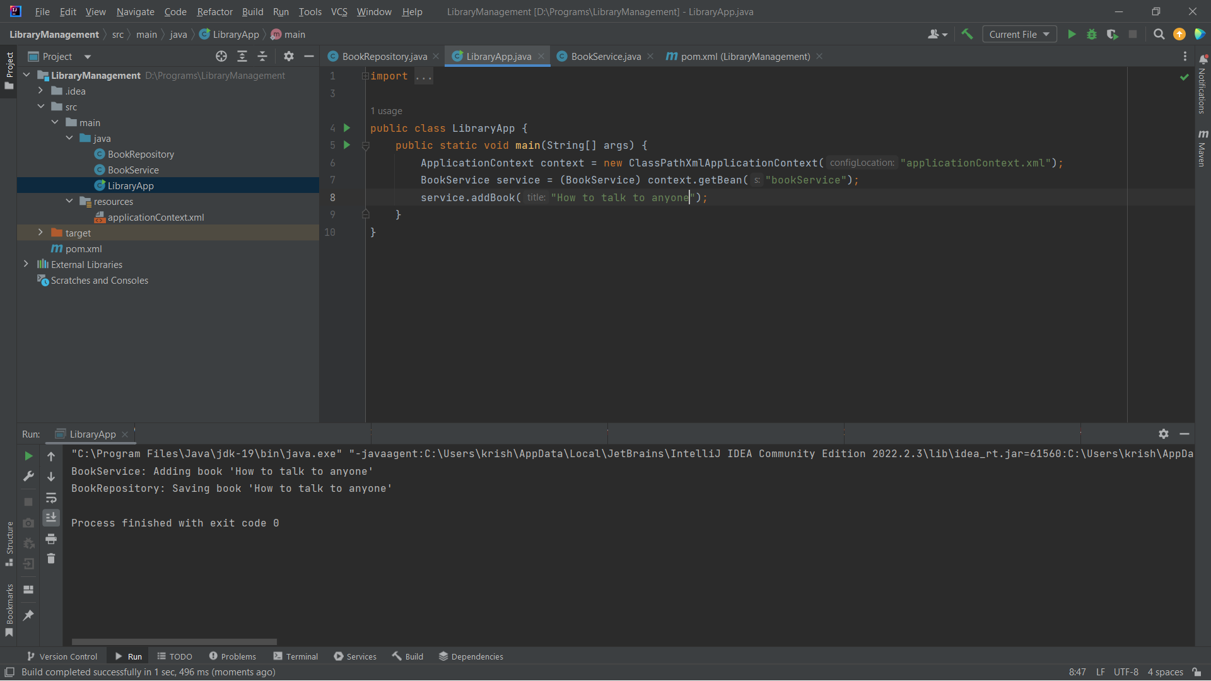

**2. Implementing Dependency Injection(same as first)**

**📄 applicationContext.xml:**

<bean id="bookService" class="com.library.service.BookService">

<property name="bookRepository" ref="bookRepository"/>

</bean>

**📄 Java Code (Setter Injection):**

public void setBookRepository(BookRepository bookRepository) {

this.bookRepository = bookRepository;

}

**💬 Explanation:**

Spring's IoC container injects the BookRepository bean into the BookService bean using the setter method. The <property> tag in the XML matches the setter method name.

**🗼 Output Screenshot:**



**4. Creating and Configuring a Maven Project**

**📄 pom.xml:**

<project xmlns="http://maven.apache.org/POM/4.0.0"

xmlns:xsi="http://www.w3.org/2001/XMLSchema-instance"

xsi:schemaLocation="http://maven.apache.org/POM/4.0.0 http://maven.apache.org/xsd/maven-4.0.0.xsd">

<modelVersion>4.0.0</modelVersion>

<groupId>com.library</groupId>

<artifactId>LibraryManagement</artifactId>

<version>1.0-SNAPSHOT</version>

<dependencies>

<dependency>

<groupId>org.springframework</groupId>

<artifactId>spring-context</artifactId>

<version>5.3.34</version>

</dependency>

<dependency>

<groupId>org.springframework</groupId>

<artifactId>spring-aop</artifactId>

<version>5.3.34</version>

</dependency>

<dependency>

<groupId>org.springframework</groupId>

<artifactId>spring-webmvc</artifactId>

<version>5.3.34</version>

</dependency>

</dependencies>

<build>

<plugins>

<plugin>

<groupId>org.apache.maven.plugins</groupId>

<artifactId>maven-compiler-plugin</artifactId>

<version>3.8.1</version>

<configuration>

<source>1.8</source>

<target>1.8</target>

</configuration>

</plugin>

</plugins>

</build>

</project>

**💬 Explanation:**

This configuration sets up the Maven project with required Spring dependencies and ensures it compiles with Java 1.8.

**🗼 Output Screenshot:**

